Mount Hope Educator Selected as 2018 NEA Foundation Global Learning Fellow
Multifaceted yearlong learning journey to prepare Julie Midkiff, students as global citizens

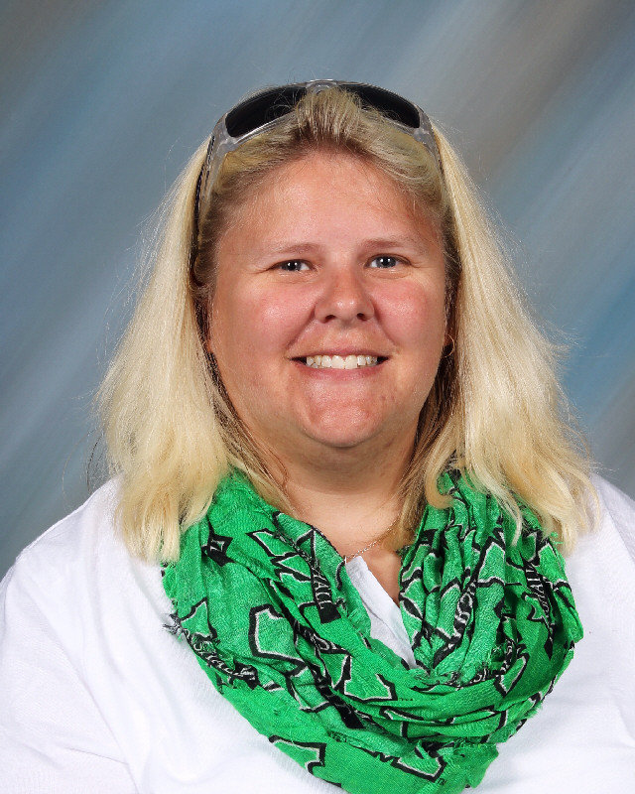
WASHINGTON, D.C. (June 13, 2017) – The NEA Foundation named Julie Midkiff, an art educator at Bradley Elementary School in Mount Hope, W.V., as one of the 48 public school educators to become a member of this year’s class of Global Learning Fellows. Midkiff will spend a year building global competency skills (the capacity to understand and act on issues of global significance).

As a result of the Fellowship, Midkiff will be better equipped to prepare students for global citizenship. Fellows also create valuable global lesson plans for their students that are freely shared with educators across the nation and the world through open-source platforms.
“By examining the differences and similarities between the visual arts and cultures around the world, my students will be able to learn about a range of diverse cultures while they are themselves learning about their own Appalachian heritage,” says Midkiff. “By comparing the two cultures, my students in their youth will gain a wider global perspective and understanding of the question of what it means to be part of a greater human family.”
This class of Fellows was selected from more than 400 applicants from across the country. These new Fellows teach all grade levels – and all subjects: from visual and performing arts to agri-science, vocational studies to history. They come from rural, suburban, and urban schools. They are National Board Certified, curriculum coaches, IB coordinators, foreign language speakers, and more. Some have participated in similar programs, and some have never traveled abroad. The diverse cohort will allow educators to learn from each other and bring global perspectives to a wide range of students.
“We believe that educators are the key to giving students the skills to thrive in an interconnected world,” said Harriet Sanford, President and CEO of the NEA Foundation. “We created the Global Learning Fellowship to provide professional development in teaching global competencies and to support educators as they integrate these skills into classroom instruction.”

Over the course of a year, the NEA Foundation staff, partners, and field experts will support Midkiff as she immerses herself in online coursework, webinars, and collegial study, including a two-day professional development workshop this fall and a nine-day international field study next summer, bringing the full cohort together with experts in global learning.

Prior Fellows have contributed valuable knowledge to the field by posting replicable lesson plans on open sourced platforms here and here. Past Fellows have returned to advance global competency in their schools and districts—one Fellow recently brought Peruvian artists to her school to teach her students how to incorporate their own culture into their art.

Get to know all of the 2018 NEA Foundation Learning Fellows by visiting neafoundation.org.
The NEA Foundation will accept applications for the 2019 Global Learning Fellowship this fall.
###

Editor’s Note: Please use our correct name, the NEA Foundation. The “NEA” is never spelled out in our name. It is not the National Education Association Foundation. Many thanks!

About the NEA Foundation
The NEA Foundation is a public charity founded by educators for educators to improve public education for all students. Since our beginning in 1969, the Foundation has served as a laboratory of learning, offering funding and other resources to public school educators, their schools, and districts to solve complex teaching and learning challenges. We elevate and share educator solutions to ensure greater reach and impact on student learning. We believe that when educators unleash their own power, ideas, and voices, communities, schools, and students all benefit. Visit neafoundation.org for more information. Find us on Facebook and Twitter, and subscribe to our blog.

